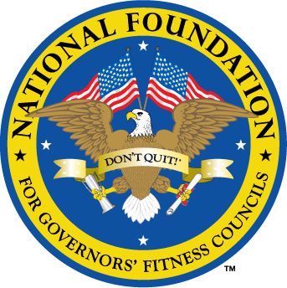
National Foundation for Governors’ Fitness Councils
DON’T QUIT! Campaign – VERMONT

Applications will be accepted from February 14, 2023 – March 26, 2023.

The National Foundation for Governors’ Fitness Councils (NFGFC) has partnered with Governor Phil Scott to bring the DON’T QUIT! Campaign to the State of Vermont this year. Our mission is to support schools that prioritize fitness and strive to be state leaders in physical education but lack the fitness resources to do so. The top three schools will receive a DON’T QUIT! Fitness Center valued at $100,000. This is a gift, not a grant.

Qualifications:
- The school must be a public or public charter school.
- The majority of students must be between the ages of 8-14 years old.
- The school must have a room on the school’s property that is available and ready for equipment installation at the beginning of the summer 2023.
- The room must be approximately 900-2000 square feet.

Please fill out the information below and email your completed application to apply@natgovfit.org.

BACKGROUND INFORMATION

School Name:
Address:
City, state, zip:
Grade levels:
Student enrollment:
Percentage of students eligible for free or reduced lunch:
Number of physical education teachers:

Your Name:
Affiliation / title:
Work phone:
Cell phone:
Email address:
Number of years you’ve worked at this school:

Principal’s Name:
Work phone:
Cell phone:
Email address:
Number of years they’ve worked at this school:

Current Equipment
Does your school currently have a fitness center or fitness equipment?
How many pieces of equipment?
What type of equipment?
What condition is it in?

Designated Room for Fitness Center
Square footage / length x width:
What floor (basement, first/ground floor, second floor) is the room on?
Height of ceiling:
Width of doors:
Earliest installation date:

VIDEO INSTRUCTIONS

Record a video where you answer the following questions:
- Why do you want a new fitness center?
- What are you currently doing to prioritize fitness?
- What do you plan to do with a new fitness center?
- What do you hope the to accomplish?

BE SPECIFIC! Get personal. Get your students and staff involved. Be creative and have fun! We are looking for passion and personality, not perfection. Videos can be filmed on a smart phone. Please keep them under 3 minutes. Download the video to YouTube and provide the link below.

Video link:

PHOTOS

Please cut and paste the following photos (in .jpg format) below:
- 3-4 photos of the room you’ve designated for the fitness center, taken from different angles.
- 3-4 photos of your school’s current equipment

Deadline: Sunday, March 26, 2023 at 11:59 pm Pacific.

This award is contingent upon a successful site visit. Please make sure you physically measure the room dimensions and submit honest answers. Save your application as a Word document (.doc/.docx) and email it to apply@natgovfit.org. For more information, visit www.natgovfit.org/apply-now.

Join our #dontquit Family! Like us on Facebook @natgovfit. Follow us on Instagram and Twitter @natgovfit.

