Independent School Newsletter  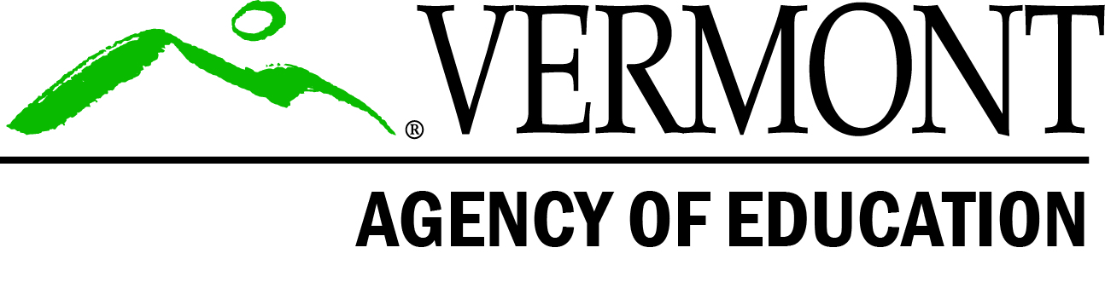 | September- October 2021
Back to School Edition  It is obvious to everyone who works in education, that COVID-19 is in attendance again this school year. This fact is exhausting for all of us engaged in education programming.  That often used trite but true phrase…”You’ve got this” is evidenced by the myriad ways schools have welcomed students back to school, as well as, providing engaging curriculum to maintain student interest.  The Independent School Team continues to be humbled by the sheer grit, creativity, fortitude, and commitment independent schools are engaged in to ensure students are not only educated by are able to access support services during another pandemic school year.  Please do not hesitate to contact a member of the AOE’s independent school team for support at:  Pat.PallasGray@vermont.gov Deborah.ormsbee@vermont.gov  In this issue:  - State Board Changes to NEASC school renewals  - Program Reminders for Start of School Year  - Tuition Rate Reminders for Special Education Schools/Programs  - Professional Opportunities  - PCB School Testing Program & Miscellaneous Information  Program Reminders for Maintenance of Approval:  Excerpt from 2017 Agency of Education  Memo  … “Approval for independent schools is granted by the Vermont State Board of Education and is subject  administrator of an approved independent school, this memorandum is a reminder of your responsibilities and obligations under current rules and regulations, which are:  Enrollment:  Enrollment changes, all new admissions or student withdrawals, after October 1, need to be reported to the AOE within five days on forms provided by the AOE. Form requests to Pat Pallas-Gray @ PallasGray@vermont.gov  Staff: New teachers, both general educators and special educators, must be reported to the AOE, accompanied by a copy of the new hire’s resume. If the new hire is a special educator, a copy of his/her valid Vermont Educator’s License endorsed in special education must also be provided. Note: when there is a change in the number of special educators available to provide special education services at your school, it is your responsibility to contact both the AOE and the Special Education Director/Coordinator in the student’s sending district/SU.  Facilities: All Independent schools are required to have a fire safety inspection conducted by the Division of Fire Safety (DFS).  However, only residential schools are required to complete a Fire Safety inspection, annually. When occupancy for educational purposes is granted by DFS, heads of schools will receive a certificate that needs to be prominently displayed in common spaces in the school, and a copy must be sent to the AOE. Residential  FAQs Continued…  schools, LEAs, members of the public at large etc.  - Proposed Rules will not be implemented until they are approved by the governing bodies that are responsible for making final determination, after the public comment period has concluded.  - At the earliest, the new Rules will be implemented for the FY23 school year. Therefore, FY22, schools will be required to meet current Rule requirements for tuition rate increases.  The tuition rate cycle for FY22 opened on January 15, 2021. The application period closes on November 15, 2021. Application, instructions, and submission information can be found below:  Application Instructions  Required Coversheet  Tuition Rate Application  To receive additional assistance when applying for a tuition rate application please contact  Deborah Ormsbee.  Exciting Professional Development Opportunities for Independent Schools  Education Quality Division staff members, Donna Stafford, and Lori Dolezal, in coordination with Networked Improvement Community, are offering a unique professional development opportunity with a particular focus on early education, pre-K – third grade.  PCB Testing in Independent Schools  An initial memo released by Vermont Department of Health, October 2020, defined air quality testing and valuation assessments regarding levels of polychlorinated biphenyls (PCBs), contaminants in school environments. Since 2020 additional work has been completed to determine how to implement safety reviews for LEAs and independent schools.  The Vermont Health Department’s webpage on PCBs describes what these contaminants are and their ill effects on health due to long-term exposure to PCBs.  “PCBs are a group of human-made chemicals that were commonly used in building materials and electrical equipment in the past and may still be in use. PCBs have been shown to have effects on the immune, reproductive, nervous, and endocrine (hormone) systems in animal studies. PCBs have also been shown to cause cancer in animals. Studies in humans show that humans could also have these health effects. Schools built or renovated before 1980 may have building materials and electrical equipment that contain PCBs.”  “HEALTH EFFECTS OF PCBS- The potential for health effects from PCBs, as with other chemicals, depends on how much, how often, and how long someone is exposed. PCBs have been shown to have effects on the immune, reproductive, nervous, and endocrine (hormone) systems in animal studies. PCBs have also been shown to cause cancer in animals. Studies in humans show that humans could also have these health effects.”  Based upon VHD recommendations, Secretary French released a survey on September 9, 2021 for LEAs and independent schools to report information on potential PCB contamination. | Program renewal changes for NEASC accredited independent schools  The State Board of Education implemented changes to the school renewal process for independent schools accredited by the New England Association of Schools and Colleges (NEASC), effective FY22.  NEASC schools, up for renewal, must provide affirmation, of important State Board of Education program areas. New requirements include:  - Fire drills in 2226.8 includes compliance with 16 V.S.A. § 1481  - Compliance with Vermont’s Public Accommodations Law (9 V.S.A. § 4500 - 4502),  - Compliance with immunizations in 2226.8 and includes compliance with 18 V.S.A. § 1121  - Compliance with health, safety, and mandatory reporting requirements in Rule 2225.7, 33 V.S.A.§ 4913  State Board Chair Olson’s entire memo  Letter to Chair Olsen: Strengthening Independent School Approval Practices  For additional information please contact Pat Pallas-Gray at: patpallasgray@vermont.gov  to the condition that the school immediately report to the Agency of Education (AOE) whenever any changes occur in enrollment, programs, policies, facilities, financial capacity, staffing, or administration during the approval period. As the schools are required to post the DFS Certificate within each residential building.  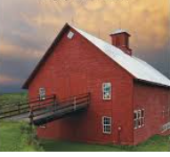  (Source: Charles H. Ormsbee Barn, East Montpelier Center, Vermont Life Magazine, 2012)  All schools, residential and non-residential, are required to contact DFS prior to any building renovations, additions, or plans to move to another location. To receive assistance please contact Pat Pallas Gray at: pat.pallasgray@vermont.gov or (802) 828-3991.”  Tuition Rate Setting, FY22:  While it is true that there are proposed changes to Independent School Rules Series 2200 before the State Board, the process for implementation has not yet been finalized. Therefore, independent schools who are required to apply for tuition rate increases are obliged to follow current Rule 2228., and corresponding subsections. Below you will find important and current information regarding rate setting.  FAQs:  - The proposed Rules were developed through a process that included many stakeholders; not just VISA and AOE. Therefore, the authors of the new rules include many voices with representatives from approved independent  Literacy Early Learning Networked Improvement Community Opportunity:  In collaboration with Nell Duke and the Council of Chief State School Officers (CCSSO), we are in the process of recruiting school teams to join us in a Networked Improvement Community (NIC) to improve early literacy instruction and student learning in PreK-K. In the NIC, we apply an improvement science approach that focuses on equity by using systems thinking, disciplined inquiry, attention to variation, and practical measures for improvement.  Most importantly, we involve those closest to the work (teachers) in the continuous improvement process, and in the co-design and development of positive classroom practices. The culminating goal of the network is to accelerate the learning, spread, and scale of positive practices.  For more information, please contact the NIC hub.  Math Early Learning Networked Improvement Community Opportunity:  In collaboration with Doug Clements, Julie Sarama, All Learners Network, and CCSSO, we are in the process of recruiting school teams to join us in a Networked Improvement Community (NIC) to improve early mathematics instruction and student learning in PreK-3rd grade.  In the NIC, we apply an improvement science approach that focuses on equity by using systems thinking, disciplined inquiry, attention to variation, and practical measures for improvement. Most importantly, we involve those closest to the work (teachers) in the continuous improvement process, and in the co-design and development of positive classroom practices. The culminating goal of the network is to accelerate the learning, spread, and scale of positive practices. For more information, please contact the NIC hub.  To assist schools with identifying potential PCB contamination sources, the Vermont Health Department site states:  “Polychlorinated biphenyls (PCBs) are a group of human-made chemicals. PCBs were widely used in building materials and electrical products in the past. Caulk, paint, glues, plastics, fluorescent lighting ballasts, transformers and capacitors are examples of products that may contain PCBs.  The U.S. Environmental Protection Agency (EPA) banned manufacturing and certain uses of PCBs in 1979. Buildings constructed or renovated between 1950 and 1979 may have building materials and electrical products that contain PCBs.”  School surveys are due September 30th to assist the state in creating a schedule for school PCB testing.  If your school has not completed the survey, please access the link below.  Secretary French’s entire weekly update on PCBs  School PCB Testing Survey: online survey

