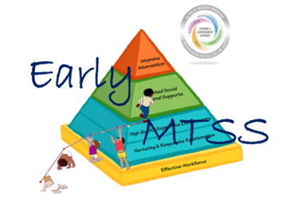
Vermont Early Multi-tiered System of Supports

Action Planning Tool

Early MTSS Leadership Teams should refer to the completed Early MTSS System Inventory results in order to complete the Early MTSS Action Planning Tool.
Early MTSS Component/Priority Area:
Desired outcome/s for this priority:
What personnel competencies will be needed to support implementing the practices/strategies to achieve these outcomes?
- Training needs:

- Coaching supports:

- Method/s for assessing staff performance:
Describe current status:
What system supports are needed to support implementing the practices/strategies to achieve these outcomes?
- Data systems needed:

- Support structures to ensure improvement:

- Method/s for assessing system performance:
Describe current status:
What leadership capacities will be needed to support implementing the practices/strategies to achieve these outcomes?
- Data systems needed:

- Support structures to ensure improvement:

- Method/s for assessing system performance:
Describe current status:

Based on the Previous Information
Implementation Drivers | What do we want to accomplish? | How will we know we have accomplished it? | What resources do we need? | Who is responsible?  What are they responsible for? | State date when we want this accomplished | Completed date when we want this accomplished
Personnel Competencies
System Supports
Leadership Capacities

Monitoring and Evaluating Our Progress
Leadership Team Review #1
Date:

Check one and describe progress made.
- Personnel Competencies

- System Supports

- Leadership Capacities
Describe necessary revisions:
Necessary Action Steps:
Leadership Team Review #2
Date:
Check one and describe progress made.
- Personnel Competencies

- System Supports

- Leadership Capacities
Describe necessary revisions:
Necessary Action Steps:

