Guidance Document for Parent Input

Purpose
The rule changes that will take place July 1st, 2022, include changes to the content of the Individualized Education Program (IEP), adding documentation of parent input. These rule changes affect what is currently section 2363.7, Content of IEP (34 CFR §300.320). The following document outlines the new language in the rule and its impact on the IEP process.
For the purposes of this and all related documents, the term ‘‘parent’’ means— (A) a natural, adoptive, or foster parent of a child (unless a foster parent is prohibited by State law from serving as a parent); (B) a guardian (but not the State if the child is a ward of the State); (C) an individual acting in the place of a natural or adoptive parent (including a grandparent, stepparent, or other relative) with whom the child lives, or an individual who is legally responsible for the child’s welfare; or (D) except as used in sections 1415(b)(2) and 1439(a)(5) of this title, an individual assigned under either of those sections to be a surrogate parent. 20 U.S.C. § 1401(23); 34 C.F.R. § 300.30

Overview
Families and educators both play a critical role in the academic, social, emotional, and behavioral development of children. When families and educators collaborate, they are more likely to succeed in helping children learn. This happens when educators invest time in to building positive and trusting relationships with their students’ family and by meaningfully collaborating with families. The rule change reviewed below reflects this principle and the need for effective engagement throughout the IEP process.

Annotated Rule Change
“The IEP shall contain a section for parents to provide written comments regarding their child’s IEP (1). Following an IEP meeting to write or amend an IEP, the LEA (Local Education Agency) shall send the IEP to the parent together with prior written notice of decision. The parent shall be provided up to 10 days (2) to complete and return the parent input section of the IEP (3). The purpose of the parent input section is to facilitate feedback from families to ensure they have an opportunity to express any opinions about the IEP or the IEP process. Upon receipt of the parent input, the LEA may, but is not required to, schedule a meeting to discuss parental concerns (4).”
- This is not meant to suggest that the parent should not have input prior to and during the IEP process. Parents should be encouraged to share their thoughts, concerns, questions, and suggestions on all sections of the IEP.
- Whenever 10 days is referenced, it is understood to mean 10 calendar days, rather than school days.
- The purpose of the parent input section is to facilitate feedback from families to ensure they have an opportunity to express any opinions about the IEP or the IEP process.
- Best practice will be to schedule a meeting to discuss the parents’ concerns and consider additional supports or services to address the parents’ thoughts in an effort to build a collaborative, trusting relationship. Regardless of the LEA’s decision to hold such a meeting, the parents’ written input must be accurately represented in the parent input section of the IEP form.
The above rule change has two primary impacts: adjustments to the IEP process, and an emphasis on successful parent engagement.

IEP Process
In order to maintain compliance with the above rule it is imperative that LEAs implement the following:
- IEP Planning: Adhere to the requirements currently outlined in rules section 2363: Individualized Education Program (IEP) (34 CFR §300.320) for conducting IEP meetings. The emphasis in this case is the inclusion of parents as active members of the process and ensuring their input as part of the discussion.
- Prior Written Notice: Following the meeting the LEA will draft the IEP including accurate representation of any specific parent input shared at the meeting in the amended present levels section (See Appendix A). The IEP is sent to the parent(s) along with Prior Written Notice Documentation and a feedback form and/or directions for how the LEA will collect Parent Input (See sample in Appendix B). Parent(s) will be informed to return the form (or other method for collecting Parent Input) within 10 days if they have additional feedback or input. If the parent declines or does not provide feedback, the LEA should indicate this circumstance within the Parent Input section of the IEP.
- Additional Feedback: If the LEA receives the completed form within ten days the LEA shall either:
  - Convene an additional meeting if the substance of parent feedback warrants such. This will usually take the form of new information not already addressed within an IEP meeting, or concerns about the IEP process that need to be addressed. In this case the LEA will confirm receipt of the feedback and may either schedule an additional formal IEP meeting for the IEP team to consider the input provided, or a specific meeting with the case manager or the special education administrator. The LEA should grant a full IEP meeting if requested by a parent. Any amendments may be created using a form 5B, as per the typical process of amending an IEP between annual meetings.
  - In writing to the parent, confirm receipt of the input and state their decision to not convene an additional IEP meeting if the substance of the additional input was already discussed and considered during the IEP meeting and that an additional meeting is not necessary. The input received will be uploaded/saved as part of the student’s IEP records.
- It is the intention of the rule to allow parent written comments to be included verbatim. The rule specifies that there must be a space on the IEP, however, the section for parent input can have a reasonable character or page limit. An LEA would be within their rights to redact with asterisk any offensive language as a way to protect their staff from abusive language.

Note: The IEP will be considered ‘in place’ from the date referenced as the implementation date in the Prior Written Notice. A later meeting to review input that amends the IEP, if held, would result in a new IEP and Prior Written Notice.

Parent Engagement
To form a successful collaboration between families and educators, it’s important that communication is clear and parental engagement and input is seen as a valuable resource. Simply having parents’ input into their child’s IEP delegated to one section of the IEP, after the IEP meeting is over does not meet the spirit of the rule. The IEP process is a critical period in which parents can tell team members who their child is beyond their test scores and classroom performance. It’s a place for them to share their perspective on their child’s strengths, challenges and needs as well as concerns, lifelong goals, and what has and has not worked for their child in the past.
It is expected that, as parents are a vital part of the IEP process, they will be meaningfully engaged to the fullest extent possible. This begins with the basic requirements, like providing procedural safeguards, and explicitly tying services to goals, but extends to ensuring equitable participation by allowing enough time for IEP meetings and working with parents to ensure appropriate accessibility. The following resources provide recommendations as to best practices and strategies to ensure that meaningful participation.

Parent Engagement Resources
The AOE has produced a series of Parent Input Case Studies. This resource breaks down examples of strategies and guiding questions that can be used to engage parents in each stage of the IEP process.
Family Engagement for Evaluation and Planning Team (IEP Team) Members: Ensuring Meaningful Participation by Families: compiled from Family Engagement Toolkit and Self-Assessment: Role Specific Guidance, Family Engagement for IEP Team Member: Ensuring Meaningful Participation by Families, pg. 60.
Strategies to consider when developing a more comprehensive approach to family engagement for families of children with disabilities and your personnel, school, or district. The strategies are organized by Family Engagement Core Principles as outlined in the Family Engagement Toolkit and Self-Assessment and align with the Family Engagement Self-Assessment. Completing the self-assessment in its entirety is recommended.
VTmtss Field Guide 2019, Component 2: Effective Collaboration, pg. 15, Reflection on Collaboration, pg. 92, VTmtss In Action: A Culture of Continuous Improvement for Equity and Excellence, pg. 63.
Effective Collaboration, a component of the VTmtss Framework, emphasizes families as a critical stakeholders of systemic processes, collective commitments, interdependence, relational trust and mutual respect.
Family Engagement: Making Connections with VTmtss: This document is intended to be used by school systems who are reviewing and improving their Family Engagement. This document would be most effective when used in conjunction with the VTmtss Systems Screener, the VTmtss Framework, and with the VTmtss Driver Diagram as an organizational tool for action planning.
Parent, Family and Community Engagement webpage: The Agency of Education recognizes the importance of partnerships between schools and families to improve outcomes and ensure equity for all students. This page provides parents/families, community members and school districts resources to advance parent/family engagement.

Appendices

Appendix A: Present Levels of Performance
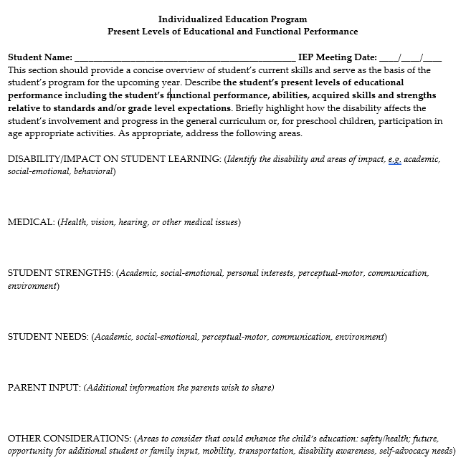

Appendix B: Example Feedback Template

Parent Input Form
Child Name: | Date of Meeting:
Date of Birth: | School Name:
Student ID Number: | School District:

Additional Student Input:
Use this section to include any strengths, opportunities, concerns, needs, potential accommodations etc. that were not considered during the meeting.

Input on Process:
I was provided my parent rights at the start of the meeting. Yes/No
I was easily able to communicate with the team and attend the meeting. Yes/No
The meeting was sufficient length to cover the required topics. Yes/No
I was asked for my input and feedback during the meeting. Yes/No
My input and feedback were incorporated when developing IEP goals and Yes/No
services and in considering the least restrictive environment for my child’s education.

Additional Comments:
Use this section to include any additional thoughts or concerns on the IEP process for your child.

