After 2 student overdoses, administrators started to cry. That’s when their school began to listen.
By Kevin O'Connor
Oct 25 2022
Share
Tweet
Share
Email
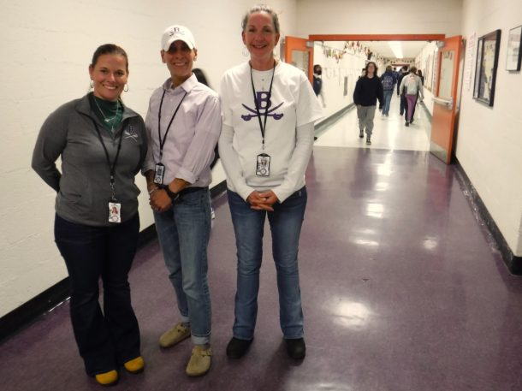From left, interim Principal Cassie Damkoehler, Assistant Principal Traci Lane and Dean of Students Hannah Parker are the new administrative team at Brattleboro Union High School. Photo by Kevin O’Connor/VTDigger
When Cassie Damkoehler came to Brattleboro Union High School as dean of students a year ago, administrators who once thought their biggest problem was the coronavirus had just discovered a gun in a student vehicle and graffiti threats about “killing you all.”
Damkoehler kept her cool as higher-ups defused the situation last fall. Then they had to launch a faculty sexual misconduct investigation last winter. Place the principal on paid leave without explanation last spring. Watch his assistant ship out for two years of military service last summer.
Returning this August, Damkoehler found herself appointed the school’s acting leader. A month later, two of its 800 students were rushed out of class upon overdosing on drugs suspected to contain the often-deadly synthetic opioid fentanyl.
That’s when, addressing an emergency assembly, Damkoehler started to cry.
“At first I didn’t want students to see me upset,” she recalled. “Then I thought I want them to see I don’t enforce rules just because we have to, I do it because this is scary and this is how we keep them safe.”
That’s when everyone else began to listen.
Brattleboro Union High School, plagued the past year by threats and turnover, is receiving public praise this fall for its swift yet sensitive response to a drug scare that local police continue to investigate.
“My child came home the day this happened and said, ‘It wasn’t all the staff standing in front lecturing — they sat down on the floor and talked to us,’” parent Bethany Ranquist told the Windham Southeast School District Board, which expressed its own appreciation at a recent meeting. “There definitely were a lot of correct steps taken that day. I’m much more impressed than I expected to be.”
The school’s new administrative team — Damkoehler, Assistant Principal Traci Lane and Dean of Students Hannah Parker — credit not only their decades of professional experience but also the fact they’re all parents of children whose lives have been upended by the Covid-19 pandemic.
“I have the perspective of what life looks like to a teenager these days,” Damkoehler said.
Added Lane: “I often check myself before I have a conversation or make a decision about how I would want someone to do this with my own child.”
And Parker: “We’ve had a lot of practice at home.”
The grade 9-12 high school — which serves Brattleboro and neighboring Dummerston, Guilford, Putney and Vernon — has faced one challenge after another since the coronavirus arrived two years ago.
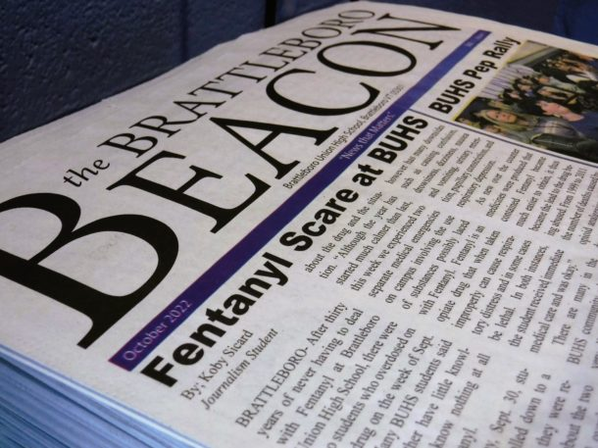Brattleboro Union High School’s student newspaper reports two recent student overdoses in the building. Photo by Kevin O’Connor/VTDigger
Students learned entirely online during the 2020 spring semester and in person only about once a week during the 2020-21 academic year. Returning to the building full-time last fall, more than half of the school responded to the gun and graffiti by staying home the Friday before Indigenous Peoples’ Day.
The beginning of 2022 promised a fresh start. Four months later, in April, Principal Steve Perrin was placed on paid leave. The school board has yet to offer an explanation — although The Commons, a Windham County weekly newspaper, recently reported that a former student was considering a lawsuit claiming Perrin made unwanted advances a dozen years ago.
Then came the two student overdoses this Sept. 28 and 30.
Upon last year’s discovery of the gun and graffiti, the school took time to craft a public statement. That pause stoked unsubstantiated rumors, social media posts and an online petition asking for more transparency.
This time, the school held assemblies within an hour of the second overdose. As dean of students, Parker emailed soon after to say anyone could share information confidentially and “you will not get in trouble.”
“We are here to help and support without consequence,” Parker wrote. “Our number one priority is for students to be safe and healthy, both physically and emotionally.”
In response, several students came forward with information.
“People who typically don’t trust the system were trusting us to try to help solve this problem,” Parker said. “We had many students share that they were super happy we were transparent about what was going on, because the rumors were way worse than what was actually happening.”
The school also emailed families by the end of the day.
“We experienced two separate medical emergencies on campus involving the use of substances possibly laced with fentanyl,” Damkoehler wrote.
In both instances, the unidentified students received immediate medical care and recovered, the administrator reported.
Not everyone agrees with the school’s response. Ricky Davidson, a counselor with the school’s Student Assistant Program, has heard from some students and parents who want tougher security measures.
“As much as that could be a way to go,” Davidson said in reply, “I went to a high school that had drug-sniffing dogs and metal detectors, and it didn’t feel like going to school; it felt like going to jail.”
A dog can overdose itself from just a few inhaled grains of fentanyl, authorities add.
The school is set to install vape sensors in bathrooms to detect the use of tobacco and marijuana. But administrators are investing more in talking with and listening to students in classrooms and their family and friends in the community.
“As much as, historically, we want to just do the suspension or the detention and hope that fixes the problem, I think it’s going to take more work,” Damkoehler said. “Addiction is a disease. We want to build a trusting connection with our students to the point where they feel comfortable sharing information with us so we can help them.”
Three weeks after the second overdose, Davidson had a long line of students outside his office. Some needed to talk. Others wanted a free lollipop.
“You can’t punish somebody out of addiction,” Davidson said. “Students are now thinking twice before they make choices, and I hope that continues. As much as this was a really horrific thing that happened, there was a lot of learning that took place in a really positive way.”
REPORT AN ERROR UPLOAD A DOCUMENTTIP DROP
Share
Tweet
Share
Email
If you want to keep tabs on Vermont's education news, sign up here to get a weekly email with all of VTDigger's reporting on higher education, early childhood programs and K-12 education policy.

