Parent Input Letter
Dear Parents,
Parents and educators both play an important role in a child’s education. When parents and educators collaborate, they are more likely to succeed in helping children learn. [SU/SD] will make sure you are an active member of the Individualized Education Program (IEP) process. The special education rule changes taking effect July 1st, 2022, provides a platform for you to engage in the process and have your input recorded as part of the written IEP. The purpose of the parent input section is to facilitate feedback from you and for you to express any opinions about the IEP or the IEP process.
For the purposes of this letter, the term ‘parent’ means a natural, adoptive, or foster parent of a child (unless a foster parent is prohibited by State law from serving as a parent); a guardian; an individual acting in the place of a natural or adoptive parent (including a grandparent, stepparent, or other relative) with whom the child lives, or an individual who is legally responsible for the child’s welfare; or an individual assigned to be a surrogate parent.
The special education rule changes include a section within the IEP for you to provide written comments regarding your child’s IEP. Following the IEP meeting [SU/SD] will draft the IEP including accurate representation of any specific parent input shared during the meeting in the amended present levels section. [Appendix A is an example of what you may see for parent input in the present levels section.] Following the meeting [SU/SD] shall send the IEP to you with prior written notice of decision. You have up to 10 days to complete and return the parent input section of the IEP if you so choose.
[SU/SD] will also seek feedback on the input process, by [a form or by other means, like the sample in Appendix B]. You will be informed to return [the form or other process] within 10 days. If you decline or do not provide feedback, [SU/SD] will indicate this within the Parent Input section of the IEP. Upon receipt of the parent input, [SU/SD] may choose to schedule a meeting to discuss parental concerns.

Resources
For questions regarding parent input, and district practices connect with your Special Education Administrator. [Name and contact information] has information about your rights and special education services in your community.
Vermont Family Network (VFN) supports and informs families of children with special needs, including assisting parents in understanding the special education process.
The Vermont Agency of Education (AOE) Special Education Resources for Families are intended to help families.
For further assistance contact the AOE’s Technical Assistance Line, 24 hours/day through the general email and voicemail system at AOE.SpecialEd@vermont.gov or (802) 828-1256.

Appendix A: Present Levels of Performance
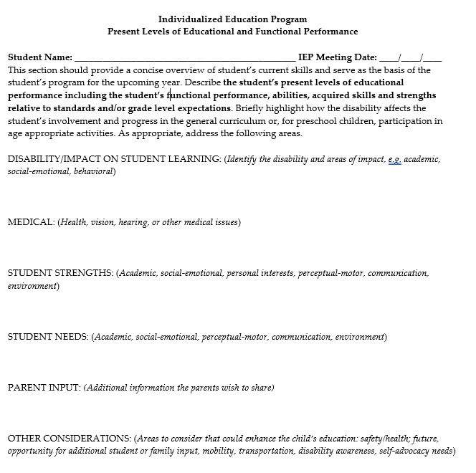

Appendix B: Example Feedback Template

Parent Input Form

Child Name: | Date of Meeting:
Date of Birth: | School Name:
Student ID Number: | School District:

Additional Student Input:
Use this section to include any strengths, opportunities, concerns, needs, potential accommodations etc. that were not considered during the meeting.

Input on Process:
I was provided my parent rights at the start of the meeting. Yes/No
I was easily able to communicate with the team and attend the meeting. Yes/No
The meeting was sufficient length to cover the required topics. Yes/No
I was asked for my input and feedback during the meeting. Yes/No
My input and feedback were incorporated when developing IEP goals and Yes/No
services and in considering the least restrictive environment for my child’s education

Additional Comments:
Use this section to include any additional thoughts or concerns on the IEP process for your child.

