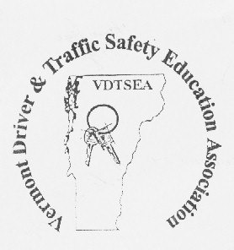
Richard Kearney
President

Karren Meyer
President-Elect

George Rooney
Past President

Suzanne Crane
Secretary

Lindsay Townsend
Treasurer

Leslie Crane
Asst. Treasurer

Charles Hess
Melissa Manson
NW Directors

Patricia Buttice
Anthony Stevens
NE Directors

Darren McIntyre.
Pamela Ricker
Central Directors

Gabriella Netsch
John Tribuna
SE Directors

Geoffrey Bloomer
Roderick Hull
SW Directors

Christopher Lynch
DMV DE Coordinator

Barbara Brody
Executive Director

Vermont Driver and Traffic Safety
Education Association, Inc.

P O Box 197
Fairfax, VT 05454
(802) 849-6146

May 22, 2020

Dear VSBPE

This is to inform you that the Vermont Driver and Traffic Safety Education Association (VDTSEA) met twice to discuss your proposal to create a Career and Technical Education sub-endorsement in the area of Driver and Traffic Safety Education. At our meeting on Friday, May 15, 2020 the board approved a motion to support in allowing an individual who has completed all the Driver Education teacher licensing courses and has been certified by the Department of Motor Vehicle as a Commercial Driver Education Instructor to apply for a Level 1 AOE endorsement without having a bachelor’s degree. The motion as stated: “The Board of Directors of VDTSEA approves and endorses the draft proposal for the CTE pathway for Driver Education Teachers to become certified public school educators.”

Although we cannot guarantee that this will eliminate the Driver Education Teacher shortage it will be another pathway for licensing. We also believe that there should be a plan to work with VTC, State Colleges and UVM Faculty in the Education Departments to promote College Juniors and Seniors who are seeking a teaching degree to also work on receiving their Driver Education endorsement along with their primary teaching endorsement. They could take the Driver Education courses as electives and upon graduation be able to apply for at least two Teacher Licensing Endorsements. We believe this is an untapped group of potential future Driver Education Teachers and this will absolutely help in the potential Driver Education teacher storage situation.

Thank you for your time. If you have any questions or concerns please feel free to contact Executive Director Barbara Brody, at 373-1623 or email bashavt@comcast.net or President Richard Kearney, 222-1982 or email rkearney@wcsu.net

Sincerely,

Barbara Brody
VDTSEA Executive Director

Richard Kearney
VDTSEA President

