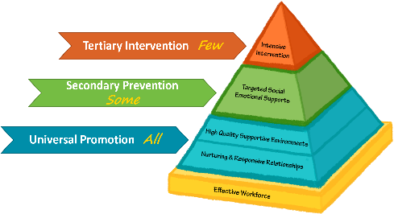
Vermont’s Early Multi-Tiered System of Supports

Preliminary Pyramid Assessment (PPA)
As a tool used within an Early Multi-Tiered System of Supports (Early MTSS) framework, the Preliminary Pyramid Assessment (PPA) was developed to guide your team in thoughtful and systematic decision-making process prior to referring a child who demonstrates challenging behaviors to referral sources such as school district Early Childhood Special Education, behavioral interventionist, Children’s Integrated Services/Early Intervention, and/or Early Childhood Mental Health, etc. The PPA will also help your team consider when it is appropriate to apply for specialized support through the Child Development Division’s Special Accommodations Grant. For your convenience, please review the quick summary of the Pyramid Model and intervention framework below.
The National Center for Pyramid Model Innovations (NCPMI) improves and supports the capacity of state systems and local programs to implement the Pyramid Model for Supporting Social Emotional Competence in Infants and Young Children (Pyramid Model), an early childhood multi-tiered system of support (MTSS), with the goal of to improving the social, emotional, and behavioral outcomes of young children with, and at risk for, developmental disabilities or delays. Implementing the Pyramid Model within early intervention and early education programs supports: 1) the reduction in the use of inappropriate discipline practices; 2) family engagement; 3) using data for decision-making; 4) integrating early childhood and infant mental health consultation; and 5) fostering inclusion. NCPMI is funded by the U.S. Department of Education Office of Special Education Programs.
NCPMI extends and deepens the work of numerous faculty members and research scholars from multiple institutions who have contributed to the development of the Pyramid Model for Promoting Social and Emotional Competence in Infants and Young Children. This work began in 2001 with the Center on the Social and Emotional Foundations for Early Learning (CSEFEL) funded by U.S. Department of Health and Human Services, Administration for Children and Families from 2001-2011 and continued through an explicit collaboration with the Center for Evidence-Based Practice: Young Children with Challenging Behavior funded by the Office of Special Education Programs in 2002 and the Technical Assistance Center on Social Emotional Intervention for Young Children funded in 2008.
The Pyramid Model provides a tiered intervention framework of evidence-based interventions for promoting the social, emotional and behavioral development of young children (Fox et al., 2003; Hemmeter, Ostrosky, and Fox 2006). The model describes 3 tiers of intervention practice: universal promotion for all children; secondary prevention to address the intervention needs for children at-risk of social-emotional delays; and tertiary interventions needed for children with persistent challenges.
The Pyramid Model was designed for implementation by early educators within child care, universal prekindergarten education programs, preschool, early intervention, Head Start, and early childhood special education programs. The framework was not designed as a path to special education services. Instead, the Pyramid Model provides a comprehensive model for the support of all children. A child receiving services through special education might be served at any of the intervention tiers.

Prevention
The effectiveness of the Pyramid Model is dependent upon the demonstrated efficacy and efficiency of the strategies used at each tier level of the pyramid. It is what we do and how we do it that makes a positive difference for a child. The short and simple of it is basically how we approach and respond to a child.
Key points to recognize:
- Tiers are fluid and children move in and out of tiers as the need/do not need supports. Children should never be categorized as a “Tier # child” because of this fluidity.
- When an intervention is provided for one child, each and every child in the classroom/program receives that intervention to maintain a continued sense of inclusion, membership, and belonging for each and every child. Data is collected on the child receiving the intervention in order to determine if the intervention is effective in supporting the child so that they may have access to and fully participate in all daily routines and activities with their peers.

So, let’s take a look at each tier of the Pyramid Model.

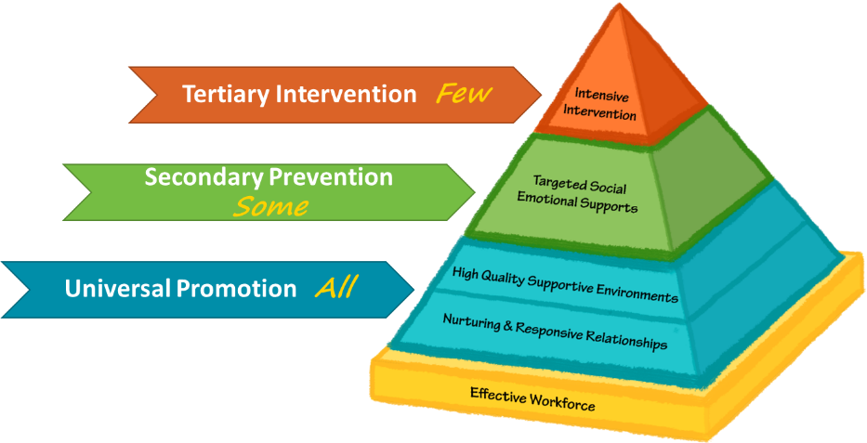

Tier 1
The first tier of the Pyramid Model involves two levels of practices that are critical to promoting the social development of young children. The first level of practices is the provision of nurturing and responsive care-giving relationships to the child. This includes the family or primary caregiver and the caregiver or teacher within an early childhood program. In addition to a focus on the relationship to the child, this level of the pyramid also describes the need for developing partnerships with families and collaborative relationships among intervention or classroom team members. The relationships level of the pyramid model includes practices such as: actively supporting children’s engagement; embedding instruction within children’s routine, planned, and play activities; responding to children’s conversations; promoting the communicative attempts of children with language delays and disabilities; and providing encouragement to promote skill learning and development.
The second level of universal promotion is the provision of supportive environments. In early care and education programs, this level of the pyramid refers to the design of classrooms and programs that meet the standards of high-quality early education. This includes the implementation of a curriculum that fosters all areas of child development, the use of developmentally and culturally appropriate and effective evidence-based teaching approaches, the design of safe physical environments that promote active learning and appropriate behavior, the provision of positive and explicit guidance to children on rules and expectations, and the design of schedules and activities that maximize child engagement and learning.

Tier 2
The secondary or prevention level of the Pyramid includes the provision of explicit instruction in social skills and emotional regulation. In early childhood programs, all young children will require adult guidance and instruction to learn how to express their emotions appropriately, play cooperatively with peers, and use social problem-solving strategies. However, for some children it will be necessary to provide more systematic and focused instruction to teach children social emotional skills. Children might need more focused instruction on skills such as: identifying and expressing emotions; self-regulation; social problem solving; initiating and maintaining interactions; cooperative responding; strategies for handling disappointment and anger; and friendship skills (Denham et al., 2003; Joseph and Strain, 2003; Strain and Joseph, 2006).

Tier 3
When children have persistent challenging behavior that is not responsive to interventions at the previous levels, comprehensive interventions are developed to resolve problem behavior and support the development of new skills. At this level of the Pyramid Model, Positive Behavior Support (PBS) is used to develop and implement a plan of intensive, individualized intervention. PBS provides an approach to addressing problem behavior that is individually designed, can be applied within all natural environments by the child’s everyday caregivers, and is focused on supporting the child in developing new skills (Dunlap and Fox, 2009; Lucyshyn, Dunlap, and Albin, 2002). The process begins with convening the team that will develop and implement the child’s support plan. At the center of the team is the family and child’s teacher or other primary caregivers. The PBS process begins with The Early MTSS Functional Behavior Assessment (Early MTSS FBA). This assessment can assist teams to better understand what the child is trying to communicate through their behavior. A child may use behaviors to gain attention, avoid or escape, gain control, to have fun/play, to self-regulate or even to gain revenge.
Functional assessment ends with the development of hypotheses about the functions of the child’s challenging behavior by the team. These hypotheses are used to develop a behavior support plan or response plan. The Early MTSS response plan is intentional as it puts the onus on the adult, instead of blaming the child. It is what the adults do to address and meet a child’s needs that will make the difference in preventing, defusing or escalating behavior. It includes evidence-based prevention strategies for caregivers to address the triggers of challenging behavior; replacement skills that are alternatives to the challenging behavior; and strategies that ensure challenging behavior is not reinforced or maintained. The response plan is designed to address home, community, and classroom routines and activities where challenging behavior is occurring. In this process, the team also considers supports to the family and strategies to address broader ecological factors that affect the family and their support of the child.

Preliminary Pyramid Assessment (PPA)
So, what should teams consider prior to making an outside referral for a child who is demonstrating challenging behaviors? It is critical to reflect on the practices you have already set in place at each of the tier levels. Always begin with Tier 1 and move on to Tier 2. In the right-hand column, please describe what your current practices look like, and sound like for each tier level strategy.

Supporting Relationships and Environments

Building Relationships
What Tier 1 strategies do you already have in place to? | What does your practice look/sound like?  Please provide specific examples.
1. Greet the child
2. Communicate at eye level
3. Interact during routine activities
4. Respond positively during routines and activities
5. Show warmth and speak calmly to child
6. Help build a relationship with you
7. Help build a relationship with peers
8. Provide positive attention throughout the day
9. Provide a comfortable, welcome and safe space for the child
10. Join in their play to support interaction and expand ideas
11. Use alternative strategies when communicating
12. Review visual schedule with child
13. Structure routines from beginning to end
14. Explicitly teach sequence of transition
15. Prepare the child for transition
16. Ensure child is actively engaged in transition
17. Provide multiple opportunities to make meaningful choices
18. Structure large group activities so child is actively engaged
19. Develop and post classroom expectations

Supportive Environment
What Tier 1 strategies do you already have in place to? | What does your practice look/sound like?  Please provide specific examples.
1. Arrange traffic patterns in classroom so there are no wide-open spaces
2. Clearly define boundaries in learning centers
3. Arrange learning centers to allow room for multiple children
4. Provide a variety of materials in all learning centers
5. Assist child to select activity and engage in activity
6. Considers child’s interests when deciding what to put in learning centers
7. Makes changes and additions to learning centers on a regular basis
8. Structure transitions so child does not have to spend excessive time waiting with nothing to do
9. Plan and conduct large group activities with specific goals in mind for the child
10. Provide opportunities for child to be actively involved in large group activities
11. Monitor child’s behavior and modifies plans when child loses interest in large group activities
12. Plan and conduct small group activities with specific goals in mind for the child
13. Use peers as models during small group activities
14. Make adaptations and modifications to ensure that the child can be involved in a meaningful way
15. Use a variety of ways to teach the expectations of specific activities so that the child can understand them

Targeted Social Emotional Supports
What Tier 2 strategies do you already have in place to? | What does your practice look/sound like?  Please provide specific examples.
1. Respond to child's ideas
2. Recognize child's efforts
3. Show empathy and acceptance of child’s feelings
4. Provide child with opportunities to make choices
5. Allow child time to respond and/or complete task independently before offering assistance
6. Create opportunities for decision making, problem solving, and working together
7. Teaches child strategies for self-regulating and/or self-monitoring behaviors
8. Utilizes peers as models of desirable social behavior
9. Encourages peer partners/ buddies (i.e., hold hands during transitions, play partner, clean-up buddy, etc.)
10. Model phrases children can use to initiate and encourage interactions
11. Give general reminders to "play with your friends"
12. Facilitate interactions by supporting and suggesting play ideas
13. Ensure that interactions are mostly child-directed not teacher-directed during free play
14. Teach appropriate social skills through lessons and role-playing opportunities
15. Incorporate cooperative games, lessons, stories, and activities that promote altruistic behavior into planning
16. Structure activities to encourage and teach sharing
17. Structures activities to encourage and teach requesting and distributing items
18. Structures activities to encourage and teach working cooperatively
19. Use photographs, pictures, and posters that portray people in various emotional states
20. Uses validation, acknowledgment, mirroring back, labeling feelings, voice tones, or gestures to show an understanding of children’s feelings
21. Assist child in recognizing and understanding how a classmate might be feeling by pointing out facial expressions, voice tone, body language, or words
22. Use real-life situations to practice problem solving, beginning with defining the problem and emotions involved
23. Teach that all emotions are okay, but not all expressions are okay
24. Label own emotional states and provides an action statement (e.g., I am feeling frustrated, so I better take some deep breaths and calm down)
25. Use opportunities to comment on occasions when children state they are feeling upset or angry but are remaining calm
26. Systematically teach the problem-solving steps:
a. What is my problem?
b. What are some solutions?
c. What would happen next?
d. Try out the solution.
27. “Problematizes" situations throughout the day to allow child opportunities to generate solutions
28. Support child through the problem-solving process during heated moments
29. Help child recognize cues of emotional escalation
30. Help child identify appropriate choices
31. Help child try solutions until the situation is appropriately resolved
32. Display photographs of child working out situations
Now that you’ve completed the PPA tier level practices the next step is to determine which practices you currently have in place, which practices are somewhat in place, and which practices still need to be put in place. Your team can begin to prioritize practices at both tier levels and begin to think about how to sustain practices in place, embed practices that are somewhat in place, and begin practices that are not in place.
The PPA supports a thoughtful and systematic process of decision making prior to referring a child who demonstrates challenging behaviors. If tier 1 and 2 evidence-based teaching practices are in place and are being implemented with fidelity it will increase all children’s social and emotional competence and confidence and will reduce the need for outside referrals. An Early MTSS coach is available in your region to support your program’s completion of the PPA, development of an action plan, and implementation of pyramid model practices. Below you will find assumptions related to implementation of pyramid model practices.
The pyramid model was designed with the following assumptions related to implementation:
- Inclusive social settings are the context for intervention
The focus of the Pyramid Model is to foster social emotional development. This requires a rich social milieu as the context of intervention and instruction. Thus, the model is designed for implementation within natural environments, interactions with the child’s natural caregivers and peers, and classroom settings that offer opportunities for interactions with socially competent peers. Interventions do not involve pull out from those settings; rather, they are dependent on a rich social context where the number of opportunities to learn and practice social skills can be optimized.
- Pyramid model tiers have additive intervention value
Each tier of intervention builds upon the previous tier. Tier 2 and 3 interventions are reliant on the provision of practices in the lower tiers to promote optimal child outcomes.
- Instructional precision and dosage increases as you move up the Pyramid tiers
The intervention practices and focus in tier 2 and 3 are not uniquely different teaching targets or approaches than the universal practices used to foster all children’s social development. The differences between tiers are evident in the specificity of the instructional target, the precision of the instructional approach, the frequency of monitoring children’s responsiveness to intervention efforts, and the number of instructional opportunities delivered to children at each level
- Data Based Decision Making (DBDM)
Data-based Decision Making is systematic teaming process, using evidence-based tools, in an equitable way, to assess, analyze and problem-solve, plan, and implement interventions for children. DBDM informs continuous monitoring efforts and next actions for individual children, as well as drives continuous improvement efforts on a larger scale, by examining patterns and trends in instruction, professional development needs, partnerships including families, and development of policies to sustain the practice.
- Efficiency and effectiveness of intervention is of primary importance
When children have challenging behavior or social-emotional risks, it is imperative that intervention is delivered quickly and effectively. There is ample research evidence that when children’s challenging behavior persists, the problems are likely to worsen and become compounded by related problems including peer and adult rejection and coercive relationships (Dodge, Coie, and Lynham, 2006; Moreland and Dumas, 2008). Thus, the Pyramid model has been provided to early educators so that practitioners and programs can provide the most effective intervention needed to immediately support the child and result in desired child outcomes. Children in need of tier 2 or tier 3 approaches should have immediate access to those interventions.
- Families are essential partners
The interventions involved in the Pyramid Model are reliant on the participation of families. All families are provided with information on how to promote their child’s social development. When children are in need of tier 2 or 3 interventions; families are involved in the provision of systematic intervention by providing increased opportunities for the child to learn and practice new skills in the context of everyday activities and routines in the home and community. When children have persistent challenges, families and other persons involved with the child form a collaborative team to develop and implement comprehensive interventions and supports that are applied in all of the child’s routines and activities.

Adapted from ‘Inventory of Practices for Promoting Social Emotional Competence’ 2006 by The Center on the Social and Emotional Foundations for Early Learning
Excerpt from ‘Response to Intervention and the Pyramid Model’ 2009 by Fox, Carta, Strain, Dunlap and Hemmeter

